**Data Visualization and Analysis Project**

**1) Which product categories have the highest total sales in the "Superstore" dataset?**

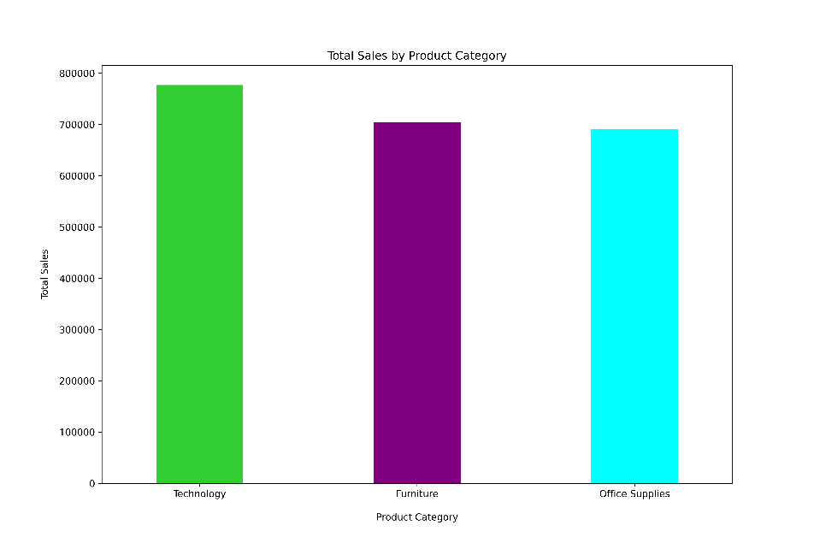

**Insight:**

* Technology products have the highest total sales, making them the top-performing category.
* Furniture comes in second, indicating moderate sales performance.
* Office Supplies have the lowest total sales among the three categories.
* These insights suggest that the Technology category is a major revenue driver and could be the focus for strategic business initiatives. Conversely, there may be opportunities to increase sales in the Office Supplies category.

**2) How do the monthly sales amounts change over the course of a year?**

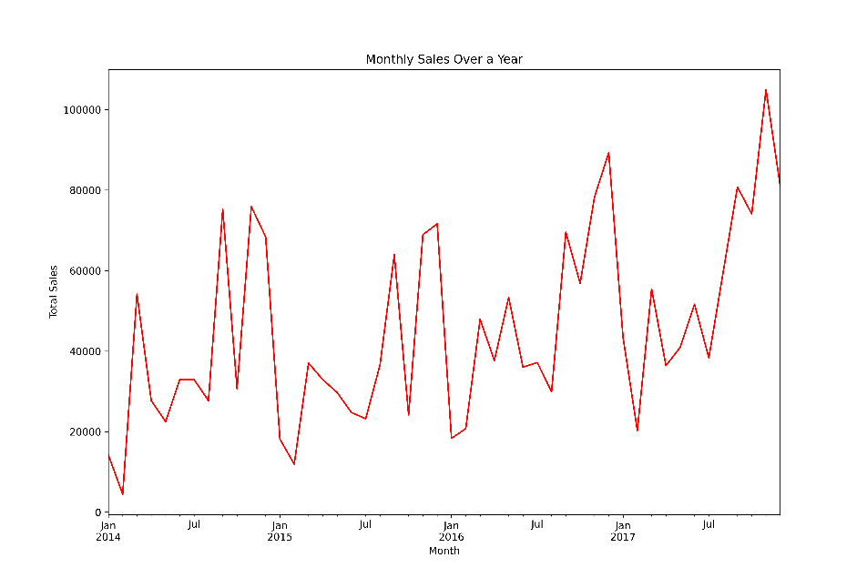

**Insight:**

* Fluctuations in sales, indicating variability from month to month.
* Seasonal trends or cyclical factors, as suggested by the peaks and troughs in the graph.
* Potential for strategic planning based on these sales patterns, such as inventory stocking or marketing campaigns during peak months.
* In summary, the sales data exhibits seasonal or cyclical variations, which are crucial for business strategy and operational planning.

**3) How is the total sales amount distributed among different product categories?**

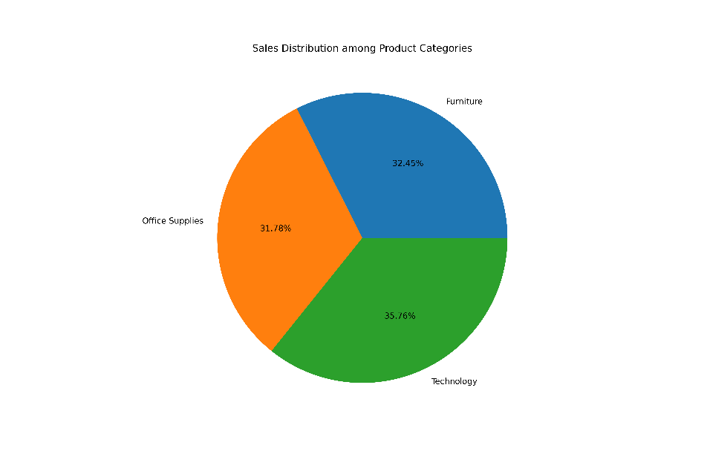

**Insight:**

* Technology has the largest share of total sales.
* Furniture and Office Supplies contribute relatively equally to the remaining sales.
* This insight indicates that Technology products are a significant revenue source within the “Superstore” dataset and could be a key focus for sales and marketing efforts.

**4) Can we analyse the sales performance of individual customers over time?**

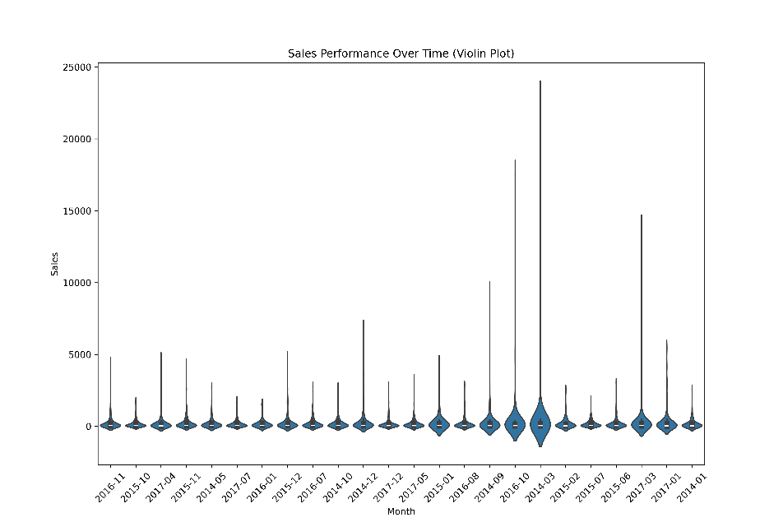

**Insight:**

* Distribution and density of sales for individual customers during different months.
* Variability in sales amounts across different time periods.
* Trends or patterns in customer purchasing behaviour over time.
* This analysis can help identify periods of high customer activity and potential opportunities for targeted marketing or sales promotions.

**5) How do sales vary based on different days of the week and product categories?**

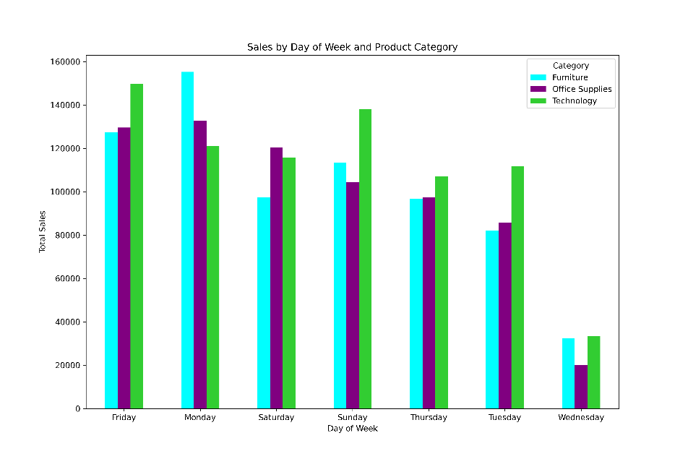

**Insight:**

* Distinct sales patterns for each product category across different days.
* Variability in sales performance, which could indicate consumer purchasing habits or operational factors like promotions and stock availability.
* Strategic opportunities to optimize sales by targeting specific days with tailored marketing for each product category.
* In essence, the chart provides actionable insights into how sales for different product categories fluctuate throughout the week.

**6) Can we visualise the sales growth of different product categories over time?**

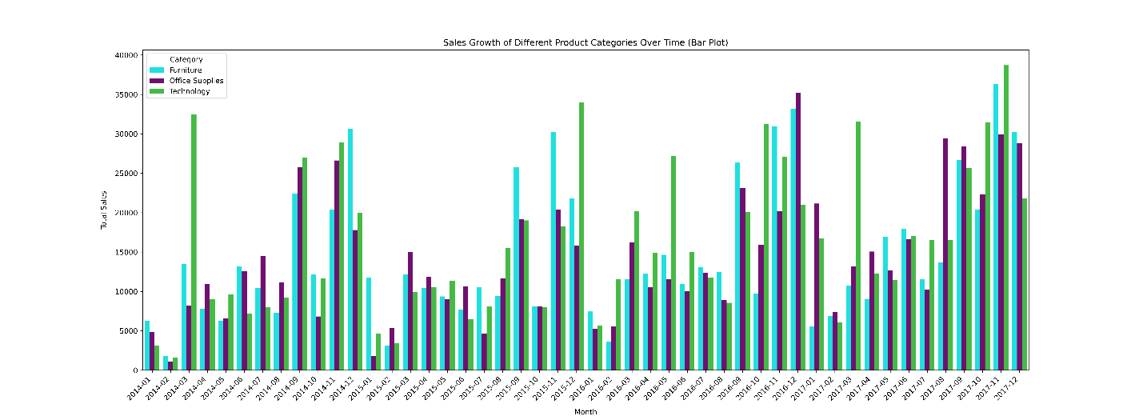

**Insight:**

* Seasonal trends in sales, with certain months showing higher sales for specific categories.
* Comparative performance of product categories, highlighting which categories are leading in sales during different months.
* Sales growth or decline patterns, which can inform inventory and marketing strategies.
* The visualization provides insights into the sales dynamics of different product categories across various months, which is valuable for strategic business planning.

**7) How does the sales distribution vary across different regions in the "Superstore" dataset?**

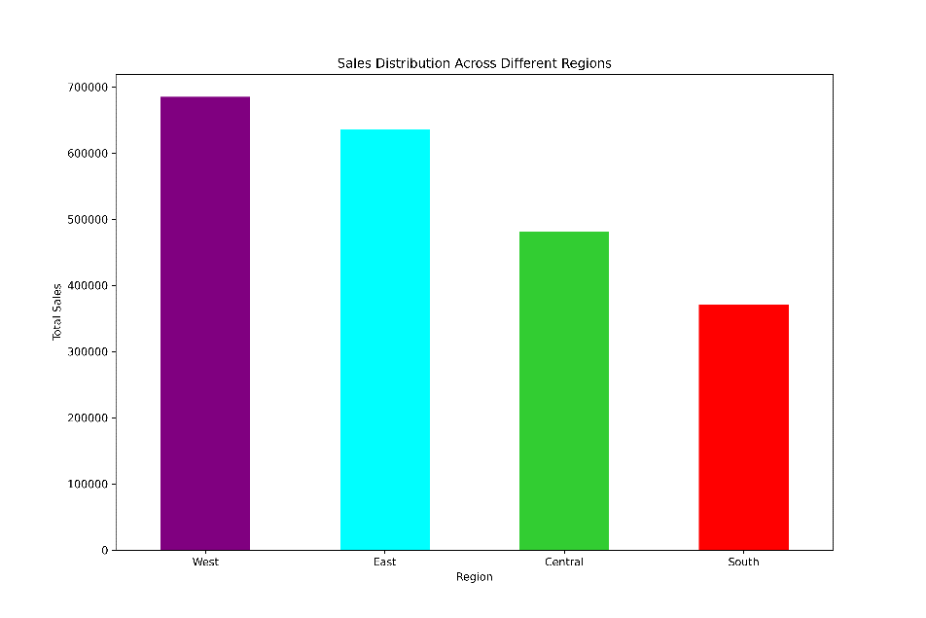

**Insight:**

* The West region leads with the highest sales.
* Followed by the East, Central, and South regions, in that order.
* This indicates that sales strategies and resource allocation might need to be tailored region-wise to optimize performance across the “Superstore” dataset.

**8) Can we visualise the composition of profits across various subcategories within different customer segments?**

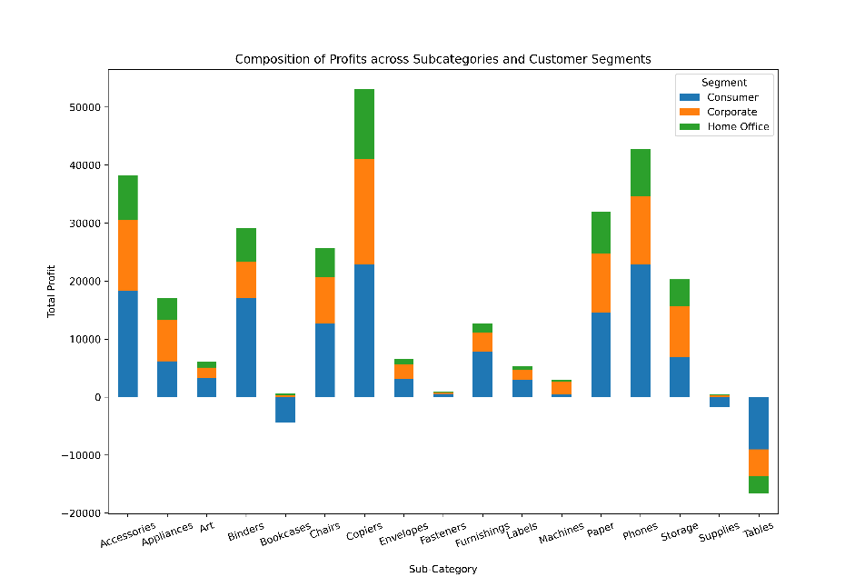

**Insight:**

* Differential profit contributions by subcategory within each customer segment.
* Stacked bars indicate the total profit for each subcategory, combining contributions from Consumer, Corporate, and Home Office segments.
* Visibility into which subcategories are most profitable and which segments are driving those profits.
* This analysis can guide targeted strategies for enhancing profitability within specific customer segments and subcategories.

**9) What is the percentage contribution of each region to the overall sales?**

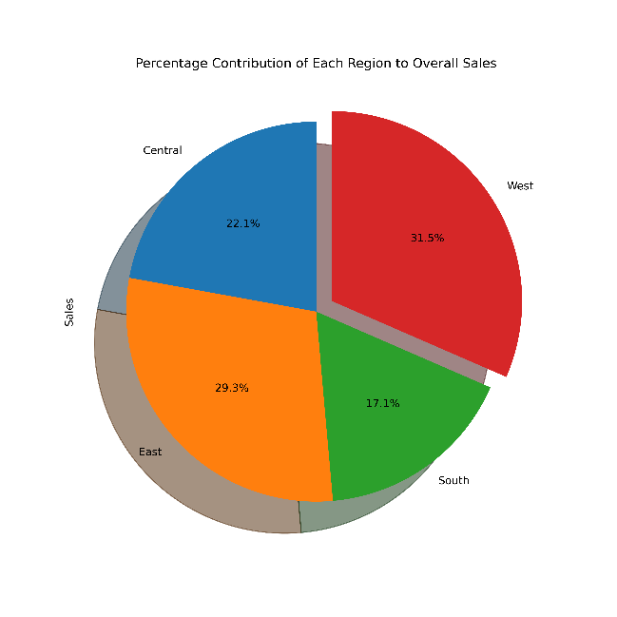

**Insight:**

* The West region is the largest contributor with 31.5% of total sales.
* The East region follows with 29.3%.
* The Central region contributes 22.1%.
* The South region has the smallest share at 17.1%.
* This indicates that the West and East regions are key areas for sales, and strategies could be focused there for further growth.

**10) Can we visualise the profit margins associated with different shipping modes and customer segments?**

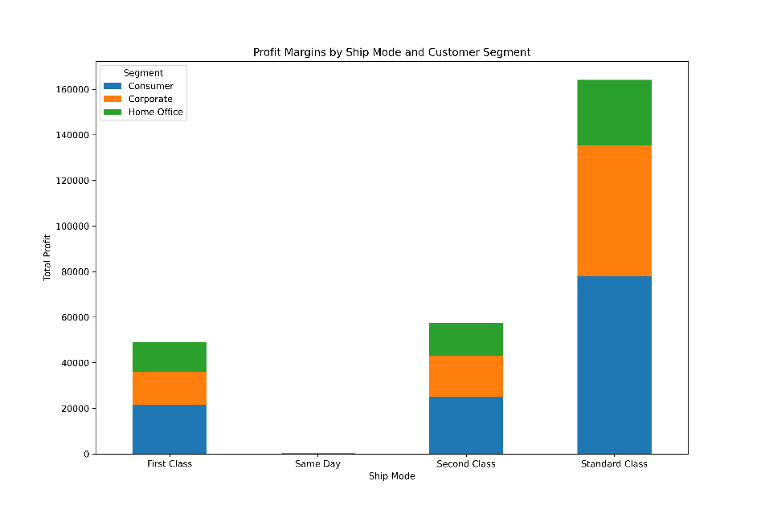

**Insight:**

* Standard Class shipping mode has the highest total profit.
* The Consumer segment is a major contributor to profits across all shipping modes.
* First Class, Same Day, and Second Class modes show a more balanced distribution of profits across segments.
* This suggests that focusing on the Consumer segment and optimizing Standard Class shipping could be beneficial for profit maximization.

**11) How long does it take to process orders for different product categories?**

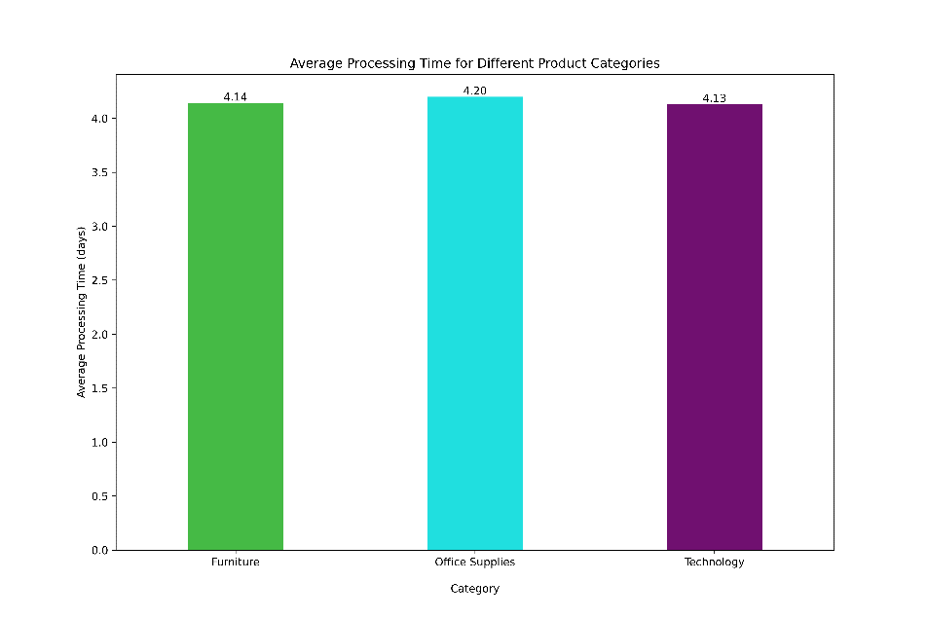

**Insight:**

* The bar plot indicates that the average processing time for orders across different product categories is approximately 4 days.
* The times are very close, with Technology at 4.13 days, Furniture at 4.14 days, and Office Supplies at 4.20 days.
* This suggests that the order processing efficiency is relatively consistent across categories.

**12) How do discounts affect overall profit?**

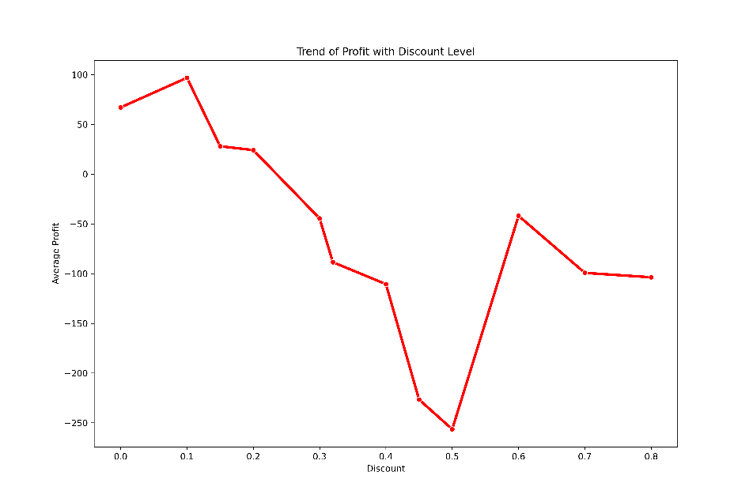

**Insight:**

* Initially, as discounts increase, average profit decreases significantly.
* There is a slight recovery in profit at a discount level just below 0.4.
* The lowest point of profit occurs at a discount level of around 0.5.
* Beyond this, there is an increase in profit as discounts rise to just over 0.6, followed by a slight decline towards a discount level of 0.8.
* In essence, higher discounts generally lead to lower profits, with some fluctuations in this trend at certain discount levels.

**13) Can we visualise the relationship between product sales and profitability for different product categories?**

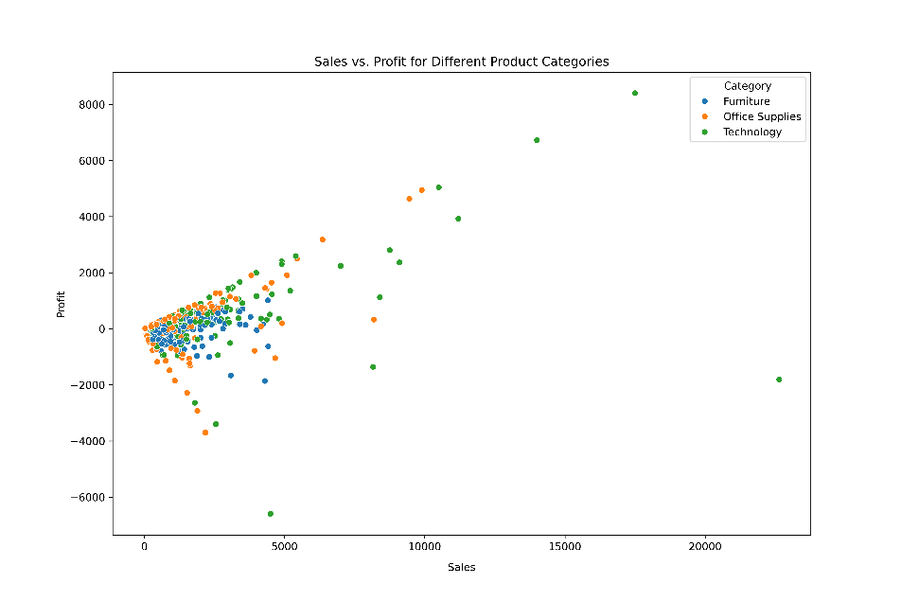

**Insight:**

* A general increase in profit with an increase in sales across all categories.
* Variability in profit at similar sales levels, suggesting that not all sales are equally profitable.
* The Technology category often achieves higher sales and profits, while Furniture and Office Supplies may sometimes incur losses despite sales.
* This suggests a need to evaluate the profitability strategies for each category, especially those with lower or negative profit margins.

**14) What is the distribution of order quantities for products in the dataset?**

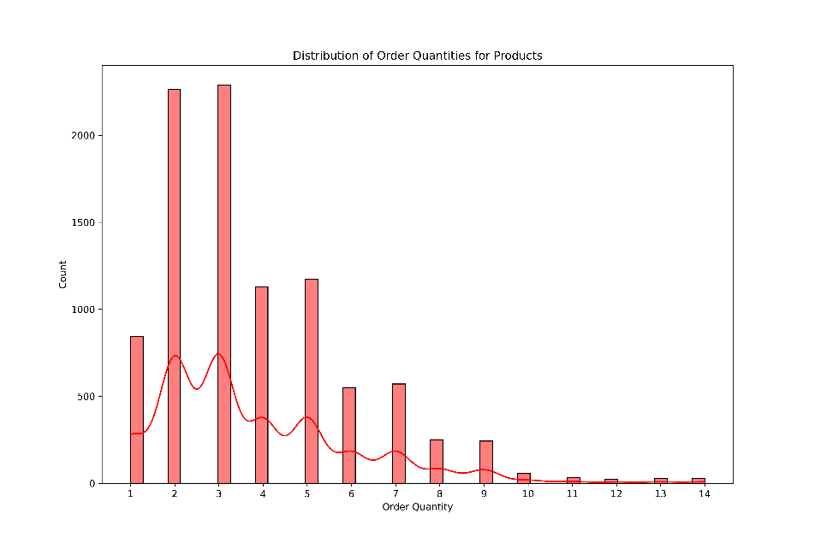

**Insight:**

* Lower order quantities are more frequent than higher ones.
* There is a peak at lower quantity values, indicating that smaller orders are common.
* The presence of multiple peaks might suggest specific preferred order sizes or bundles.
* This information is valuable for understanding customer purchasing behaviour and can guide inventory and supply chain decisions.

**15) How do the profit distributions vary across different product categories?**

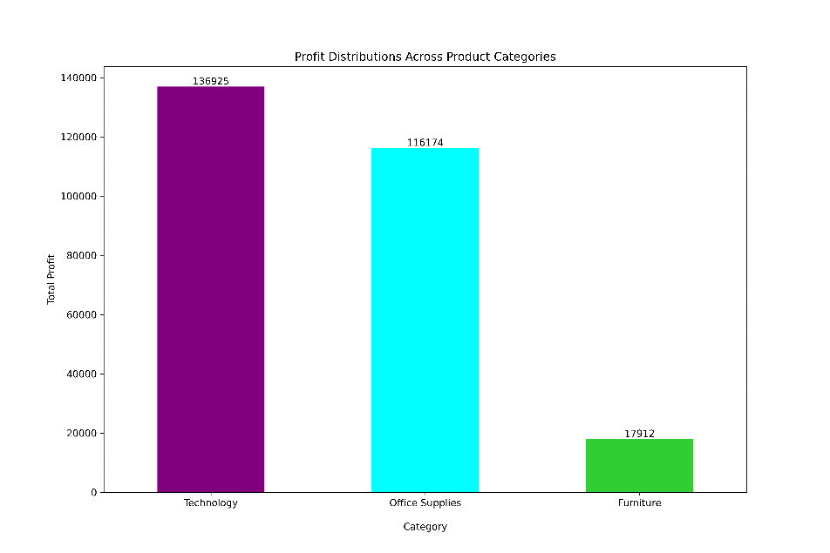

**Insight:**

* Technology is the most profitable category with the highest total profit.
* Office Supplies is the second most profitable category.
* Furniture has the lowest total profit among the three.
* This insight can guide businesses to focus on the Technology category for higher profitability and to explore strategies to improve profits in Furniture and Office Supplies.

**16) Can we compare the shipping time distributions for different shipping modes?**

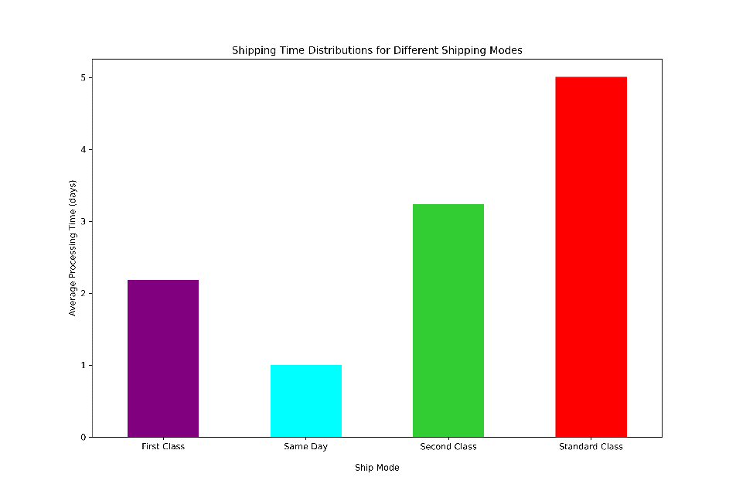

**Insight:**

* The average processing time in days for each shipping mode.
* Differences in processing time between modes such as First Class, Same Day, Second Class, and Standard Class.
* This information is crucial for customers to make informed decisions about shipping and for businesses to evaluate and potentially improve their shipping services.

**17) What is the monthly trend in the number of orders shipped?**

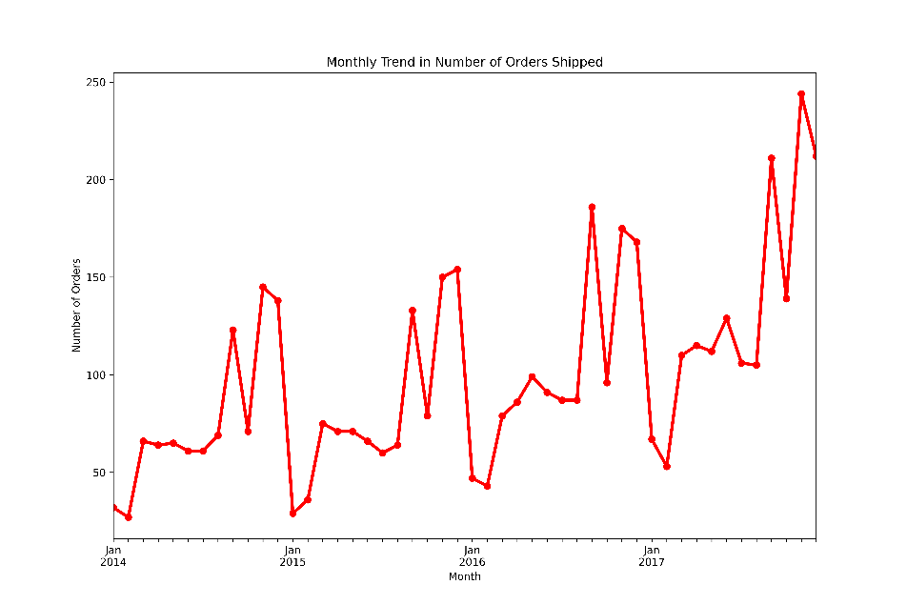

**Insight:**

* A general upward trend in the number of orders over the years.
* Seasonal patterns, with certain months exhibiting higher numbers of orders, likely due to increased demand during holidays or sales seasons.
* This insight can help businesses prepare for periods of high demand and optimize their supply chain and inventory management accordingly.

**18) How do different customer segments perform in terms of sales and discount rates?**

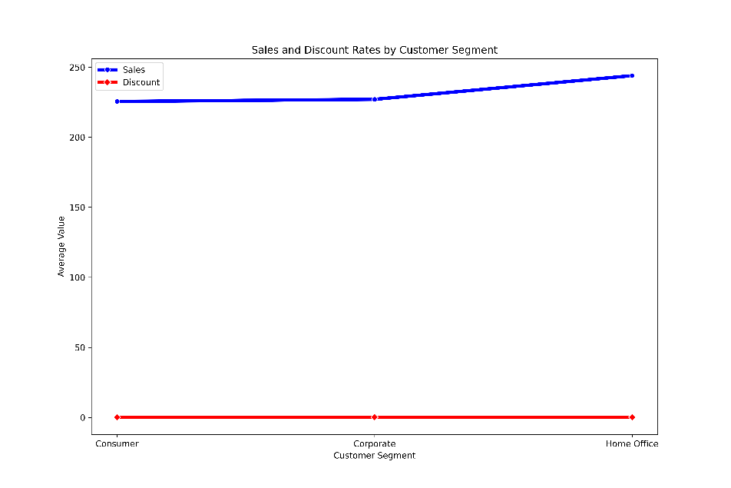

**Insight:**

* An upward trend in average sales from the Consumer to the Home Office segment.
* The discount rates are relatively consistent across segments, with no significant variation.
* This suggests that while sales performance improves from Consumer to Home Office segments, the discount strategy remains uniform across different customer types.

**19) What are the sales and profit trends across different product subcategories and regions in the Superstore dataset?**

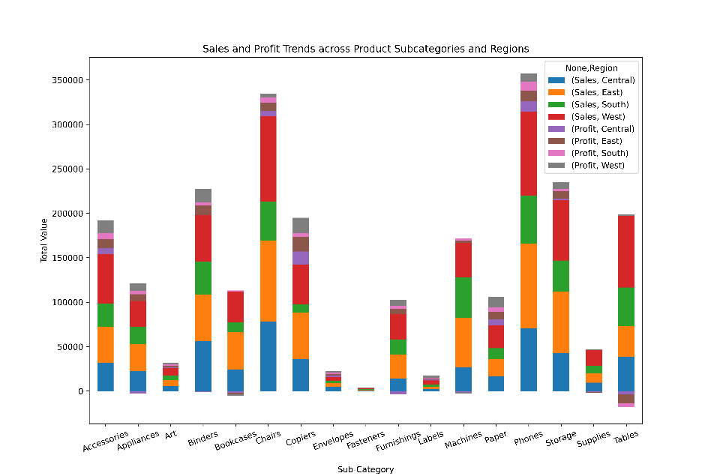

**Insight:**

* Varied performance in sales and profits across subcategories and regions.
* Some subcategories show high sales and profits in certain regions, while others do not perform as well.
* The chart can identify regional market strengths and areas where profit margins could be improved.
* This information is valuable for tailoring regional sales strategies and optimizing product offerings to enhance profitability.

**20) What is the average delivery duration for different regions and ship modes?**

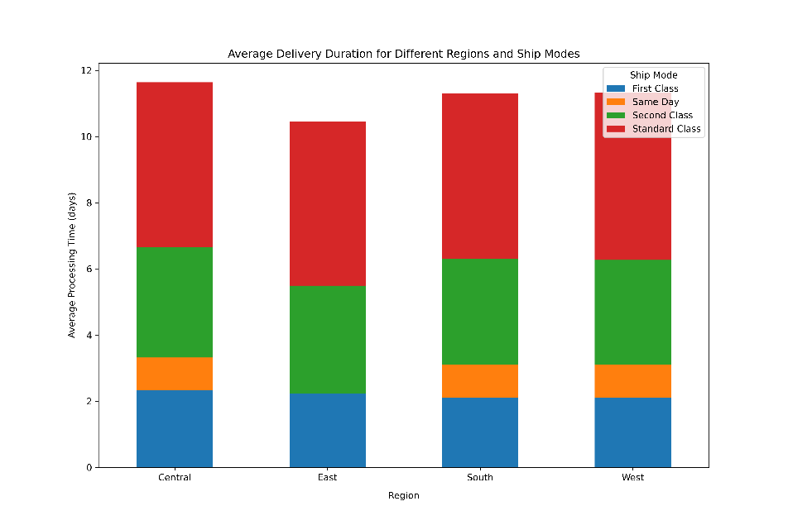

**Insight:**

* Standard Class generally has the longest delivery times across all regions.
* Same Day shipping mode offers the shortest delivery times.
* The Central region exhibits the longest delivery times for Standard Class shipping, while the West region has shorter delivery times across all shipping modes.
* This information suggests that customers in the Central region may experience longer waits for Standard deliveries, and those requiring quicker deliveries should consider Same Day or First Class options, especially in the West region where processing times are lower.

**21) How has the average order quantity changed over the years for various product categories?**

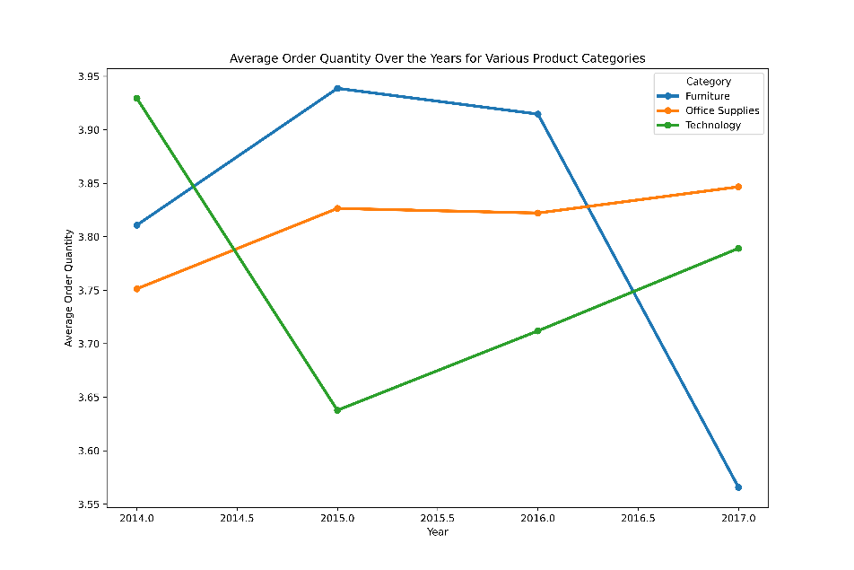

**Insight:**

* Furniture: Slight decrease in average order quantity.
* Office Supplies: Stable average order quantity with minor fluctuations.
* Technology: Increasing trend in average order quantity from mid-2016.
* These trends provide insights into consumer purchasing behavior and can inform inventory and sales strategies.

**22) Can we visualise the correlation between discount rates and order quantities for different customer segments?**

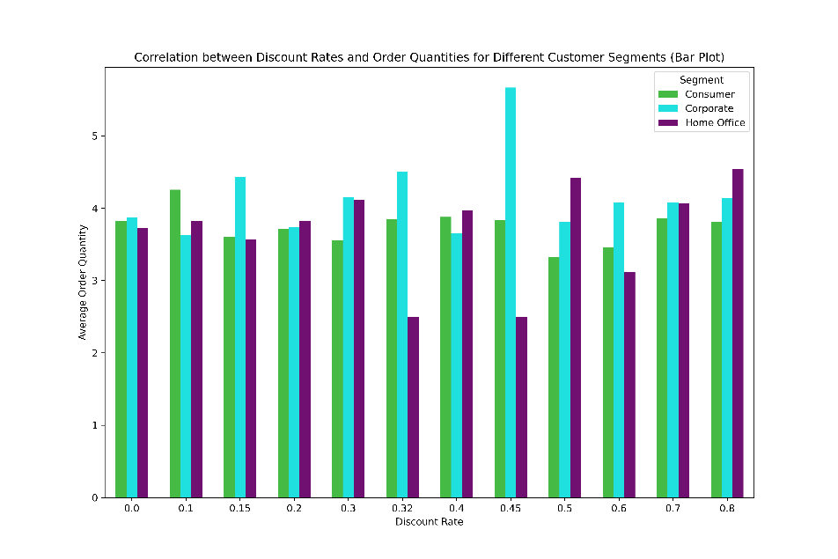

**Insight:**

* Higher discount rates generally correlate with increased order quantities across customer segments.
* Segment 1 exhibits the highest order quantities, particularly at a discount rate of around 0.5.
* Beyond a discount rate of 0.5, order quantities for most segments plateau or slightly decrease, except for Segment 1.
* This indicates that while discounts can incentivize larger orders, there may be a threshold beyond which additional discounts do not significantly increase order quantities.

**23) What is the proportion of orders returned in each region within the Superstore dataset?**

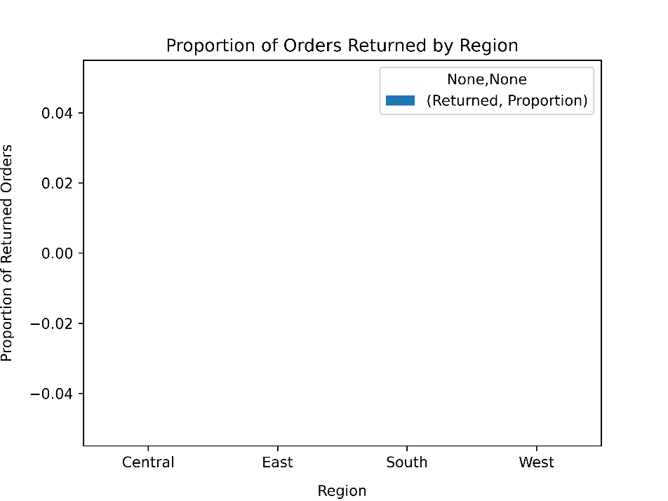

**Insight:**

* A low return rate in a business indicates operational efficiency, high customer satisfaction, and quality assurance.
* It helps reduce costs, increases profitability, ensures customer loyalty, and maintains a reliable supply chain.
* A low return rate boosts profits, nurtures customer loyalty, and provides a competitive edge by showcasing a business’s reliability and efficiency.

**24) Can you compare the profit of different products for different subcategories?**

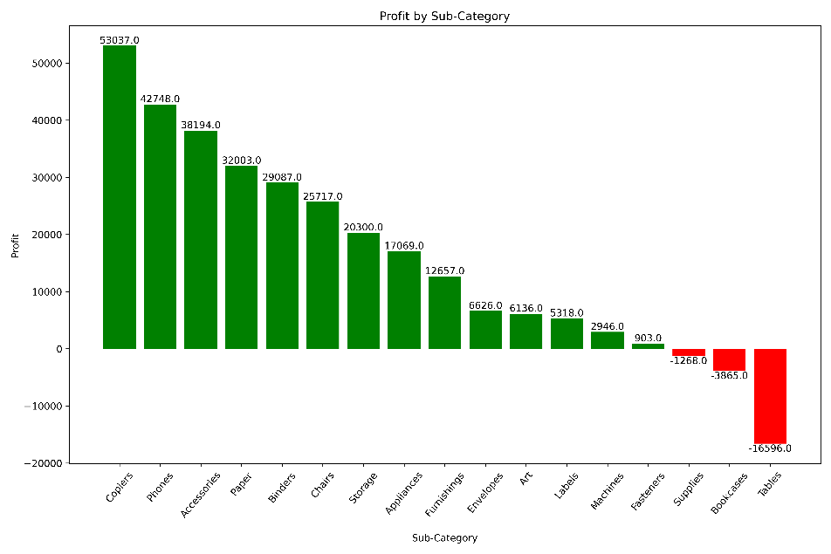

**Insight:**

* Copiers is the most profitable sub-category.
* Tables is the least profitable, incurring significant losses.
* There is a wide variance in profitability across different sub-categories.
* Strategic decisions can be made to focus on profitable sub-categories and improve or revaluate the less profitable ones

**25) Which shipping mode is the most commonly used in the Sample Superstore dataset?**

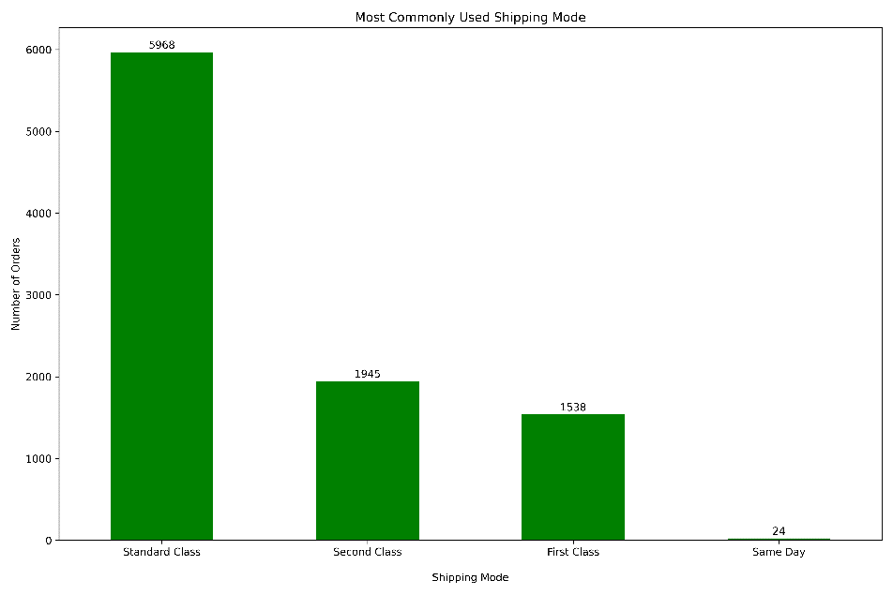

**Insight:**

* The most commonly used shipping mode in the Sample Superstore dataset is Standard Class, as indicated by the highest number of orders.
* This suggests that customers may prefer this mode for its balance of cost and delivery time.

**26) How does the sales performance of different regions evolve throughout the quarters of a year?**

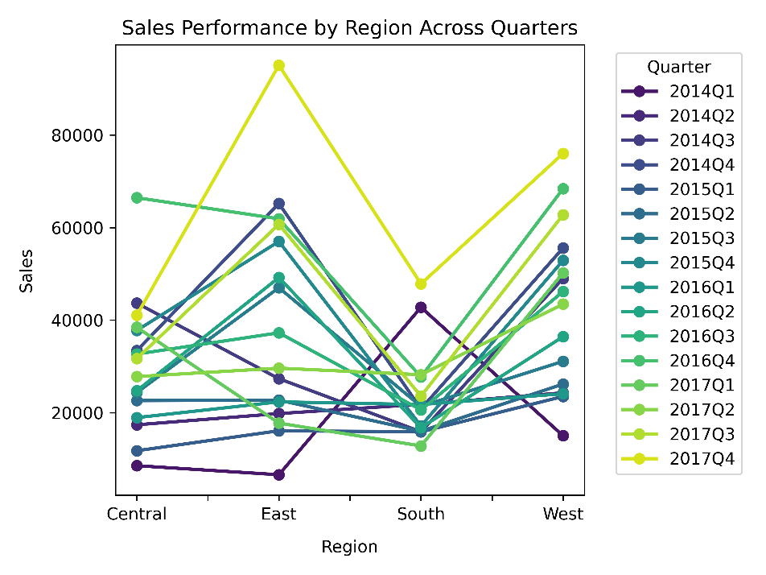

**Insight:**

* Seasonal fluctuations in sales across all regions.
* The West region generally has higher sales figures across most quarters.
* A notable peak in sales for the East region in 2016Q3.
* Seasonality is evident, with peaks and troughs at various points throughout the years.
* These insights can inform strategic planning for seasonal sales cycles and regional market focus.

**27) What is the distribution of order priorities across different product categories?**

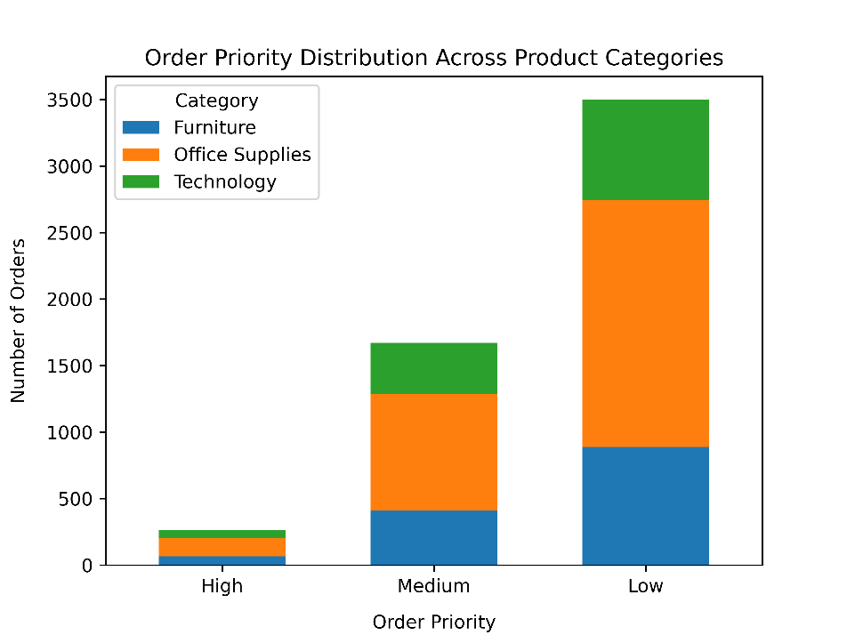

**Insight:**

* Office Supplies have the highest number of orders across all priority levels.
* Low priority orders are the most common, followed by Medium and then High priority orders.
* Customers tend to order Office Supplies more frequently than Furniture or Technology, regardless of the order priority level.
* This suggests that Office Supplies are essential items that are consistently ordered, while Furniture and Technology may be considered more discretionary or infrequent purchases.

**28) What is the relationship between discounts and sales?**

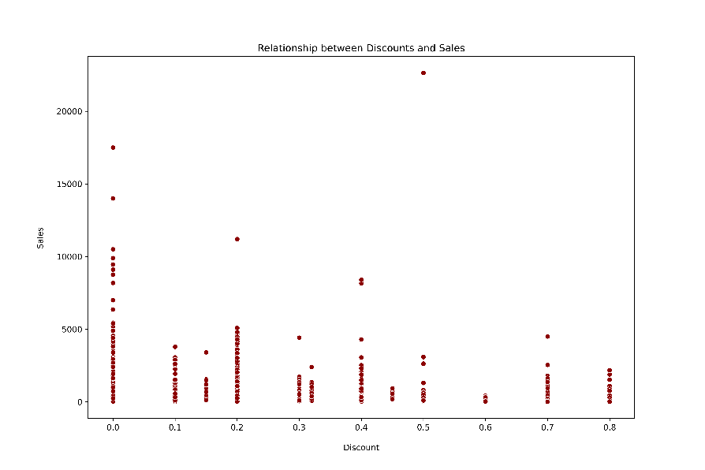

**Insight:**

* No Strong Correlation: The data points do not show a strong or consistent correlation between higher discounts and increased sales. Most sales are concentrated at lower discount rates.
* Higher Discounts, Not Always More Sales: While there are sales across all discount levels, higher discounts do not guarantee a proportionate increase in sales volume.
* This suggests that while discounts can influence sales, they are not the sole factor, and other elements like product demand, competition, and customer preference might also play significant roles. It’s important for businesses to consider these factors when setting discount strategies.

**29) How does the average order value differ between repeat customers and new customers?**

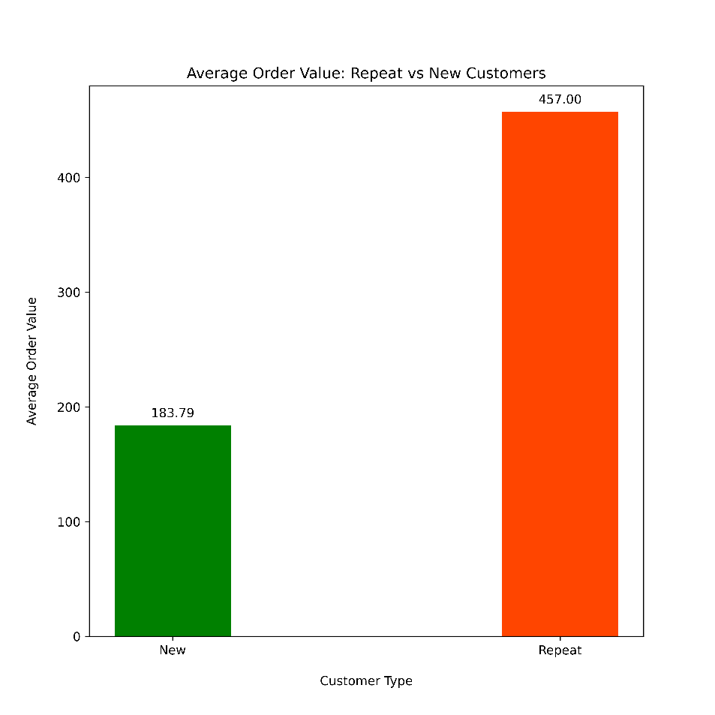

**Insight:**

* Higher Value for Repeat Customers: Repeat customers have an average order value of $457.00, which is substantially higher than the $183.19 average order value of new customers.
* This suggests that repeat customers tend to spend more per order, highlighting their importance in terms of revenue and the potential benefits of focusing on customer retention strategies.

**30) What is the geographical distribution of returns and its impact on overall profitability?**

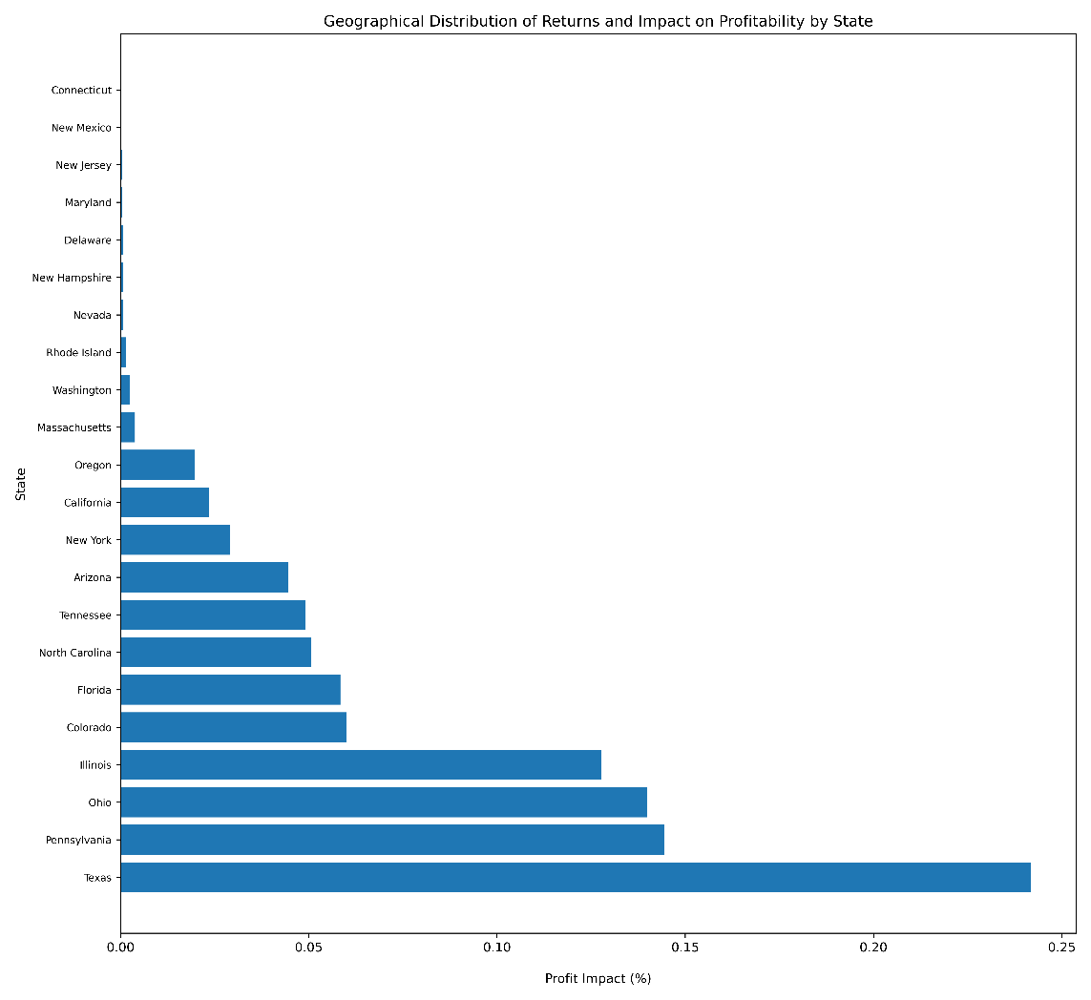

**Insight:**

* Varied Impact Across States: The chart shows that returns have a varied impact on profitability across different states, with some states experiencing a higher percentage impact on profits due to returns.
* Need for Tailored Strategies: This suggests that return management strategies may need to be customized for different states to optimize profitability.
* Understanding these geographical differences is key for businesses to develop targeted approaches to minimize the negative financial impact of returns.